Typescript is a open source programming language developed by Microsoft that is built on top of Java script by adding static typing. Typescript is wrapper on the java script language. Typescript is java script with extra features that helps to catch error early and make code easier to understand and maintain.
Typescript file has .ts extension. Java script has .js extension. They are compiled down to regular javascript and we can run using browser or nodejs.
In static typing we can use types like Boolean, string, number which we don’t do in Java script. Java script is powerful and flexible but that flexibility can lead to mistake.
Javascript-> We create a function which accepts 2 parameters. We add the number and return it. If we call the function by passing an integer and String still we get the addition result.
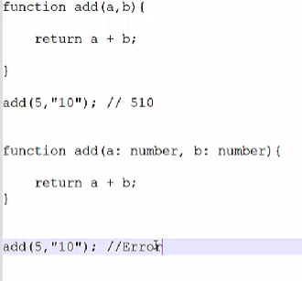
Typescript: If we do the same thing using typescript it will throw an error “Argument of type String is not assignable to parameter of type number”

The good thing is that we will not get this error in runtime but in compile time. Type checking helps to catch bug before runtime.
Prerequisites:
- NodeJS
- Visual Studio Code
- Typescript
- Ts-node

